Running Your Monthly Activity Report

Log into the Bank of America Merrill Lynch Works system located at the following URL: http://payment2.works.com/works
From the homepage, click on the Reports navigation tab and select Create from the drop-down list.
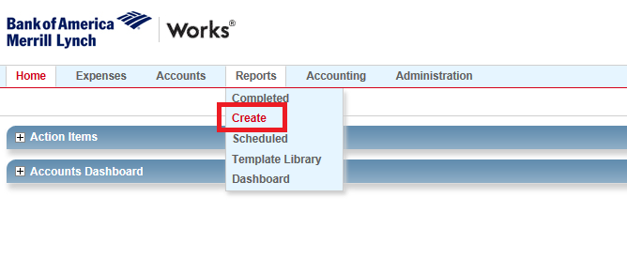

On the following screen select Spend as the Category and select OLR Monthly SPCC Transactions (CH & MGR) from the drop-down list. If this option is not an available recent report, select the “Choose from all available templates…” option at the bottom of the drop-down menu and select the OLR Monthly SPCC Transactions (CH & MGR) in the pop-up window that follows.
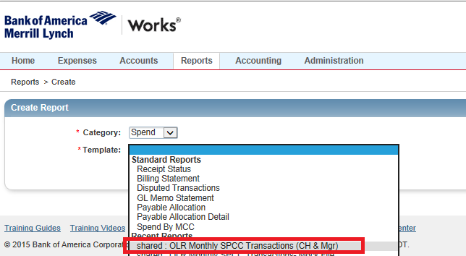
When you arrive at the report configuration screen, confirm that the correct Post Date is showing (this field will always default to the previous billing cycle). Finally, click on the blue submit report button located in the lower right corner of the page to run your report.
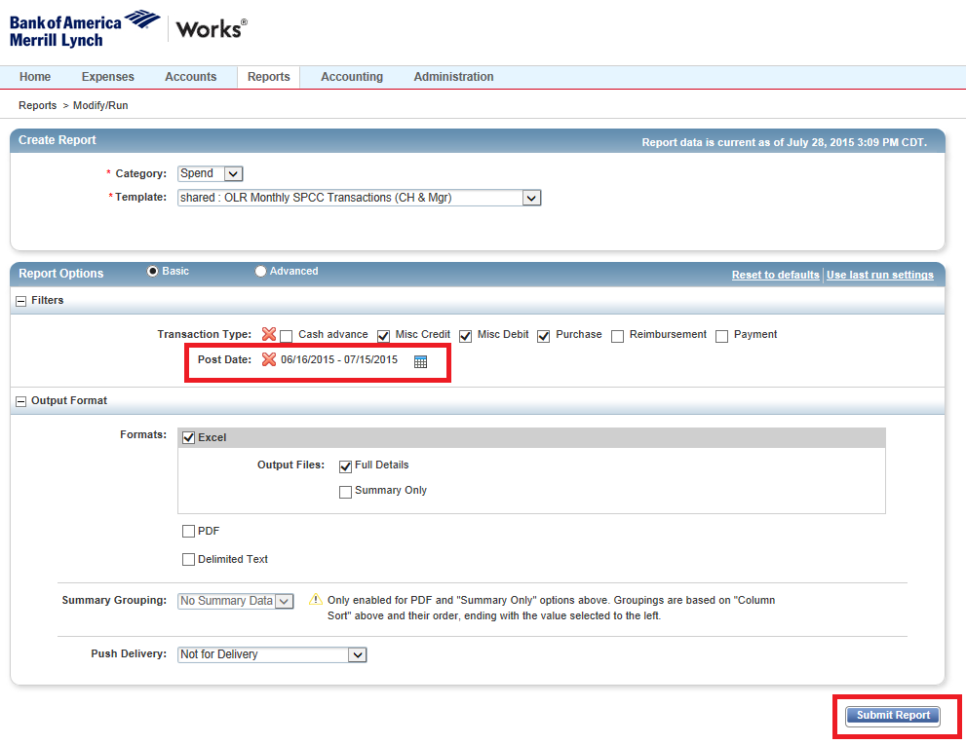
After clicking on the Submit Report button, the system will redirect you to the Completed Reports Page. When the report is ready, an “XLS” link will appear in the Output Types(s) column. Clicking on this link will download your report.
